Laboratory L01 – HTTP
1. X.
Example
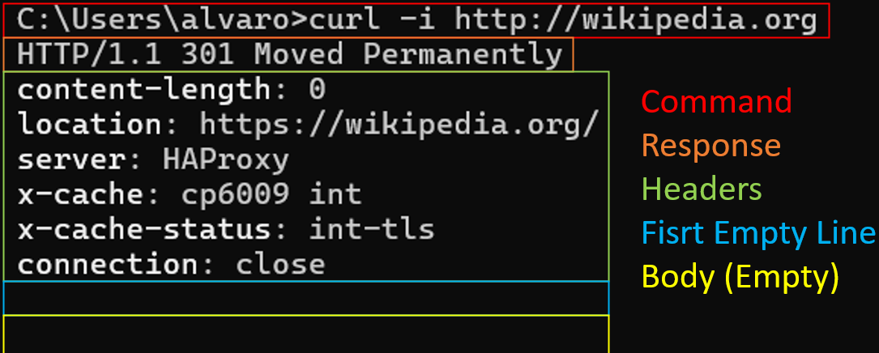
2. X.
Example

